**MINISTRY OF EDUCATION AND TRAINING**

**FPT UNIVERSITY**

Capstone Project Document

**Vietnamese Sign Language Recognition**

|  |  |
| --- | --- |
| **Group 05** | |
| **Group members** | Nguyễn Hữu Kỳ Long – Team leader – SE60984  Nguyễn Đình Tân – Team member – SE61115  Nguyễn Xuân Ý – Team member – SE60869  Lê Phương Bình – Team member – SE61049 |
| **Supervisor** | Mr. Đỗ Đức Minh Quân |
| **Ext. Supervisor** | N/A |
| **Capstone Project code** | VSLR |

-Ho Chi Minh City, 17/05/2015-

*This page is intentionally left blank*

# Table of Contents

Table of Contents 3

List of Tables 5

List of Figure 5

Definitions, Acronyms, and Abbreviations 7

A. Report No. 1 Introduction 8

1. Project Information 8

2. Introduction 8

3. Current Situation 8

4. Problem Definition 8

5. Proposed Solution 8

5.1 Feature functions 9

5.2 Advantages and disadvantages 9

6. Functional Requirements 9

6.1 Tracking hand 9

6.2 Hand recognition 9

6.3 Showing the content 9

6.4 Learning hand sign 9

6.5 Controlling System 9

6.6 Controlling power 9

7. Role and Responsibility 10

B. Report No.2 Software Project Management Plan 10

1. Problem Definition 10

1.1 Name of this Capstone Project 10

1.2 Problem Abstract 10

1.3 Project Overview 10

Figure 1: Components of the the system 13

2. Project organization 14

2.1 Software Process Model 14

Figure 2 : Scrum Development Model 15

2.2 Roles and responsibilities 15

2.3 Tools and Techniques 16

3. Project Management Plan 17

3.1 Product Backlog 17

3.2 Sprint Backlog 19

3.3 Sprint Burndown Chart 23

Figure 3: Chart of Sprint Backlog 23

3.4 All Meeting Minutes 24

4. Coding Convention 33

C. Report No. 3 Software Requirement Specification 33

1. User Requirement Specification 33

2. System Requirement Specification 34

2.1 External Interface Requirement 34

2.2 System Overview Use Case 35

Figure 4: System Overview Use Case 35

2.3 List of Use Case 36

Figure 5: Select Function use case diagram 36

Figure 6: Recognize Hand Sign Language use case diagram 38

Figure 7: Learn sign use case diagram 40

Figure 8: Learn sign use case diagram 42

3. System Attribute 45

3.1 Usability 45

3.2 Reliability 45

3.3 Availability 45

3.4 Security 45

3.5 Maintainability 45

3.6 Portability 45

3.7 Performance 46

D. Report No.5 System Implementation & Test 46

1. Introduction 46

1.1 Overview 46

1.2 Test Approach 46

2. Database Relationship Diagram 46

2.1 Physical Diagram 46

Figure 52: Physical Database Diagram 46

2.2 Data Dictionary 46

3. Test Plan 47

3.1 Test items 47

3.2 Features to be tested 47

3.3 Features not to be tested 47

- N/A 47

3.4 Environmental needs 47

3.3 Test case pass/fail criteria 47

4. Integration Test Specifications 48

4.1 “Background Color Subtraction” Test 48

Figure 52: Components of the Background Color Subtraction 48

4.2 “Selecting Function” Test 53

Figure 52: Components of the Selecting Function 53

4.3 “Hand Sign Language Recognition” Test 58

Figure 52: Components of the Hand Sign Language Recognition 58

4.4 “Learning Hand Sign Language” Test 63

Figure 52: Components of the Selecting Function 63

4.5 “Monitor Battery Capacity” Test 70

Figure 52: Components of the ??? 70

4.6 “Charging Battery” Test 73

Figure 52: Components of the ??? 73

# List of Tables

Table 1: Roles and Responsibilities 10

Table 2: Roles and Responsibilities Details 16

Table 3: Product Backlog Details 18

Table 4: Sprint Backlog Details 22

Table 5: Definitions, Acronyms, and Abbreviations 24

Table 6: Scrum Meeting Minutes Detail 32

# List of Figure

Figure 1: Components of the the system 13

Figure 2 : Scrum Development Model 15

Figure 3: Chart of Sprint Backlog 23

Figure 4: System Overview Use Case 35

Figure 5: Select Function use case diagram 36

Figure 6: Recognize Hand Sign Language use case diagram 38

Figure 7: Learn sign use case diagram 40

Figure 8: Learn sign use case diagram 42

Figure 52: Physical Database Diagram 46

Figure 52: Components of the Background Color Subtraction 48

Figure 52: Components of the Selecting Function 53

Figure 52: Components of the Hand Sign Language Recognition 58

Figure 52: Components of the Selecting Function 63

Figure 52: Components of the ??? 70

Figure 52: Components of the ??? 73

# Definitions, Acronyms, and Abbreviations

|  |  |
| --- | --- |
| **Name** | **Definition** |
|  |  |
| VSLR | Vietnamese Sign Language Recognition |
| LCD | Liquid crystal display |
|  |  |

# Report No. 1 Introduction

## Project Information

* Project name: **Vietnamese Sign Language Recognition**
* Project Code: **VSLR**
* Product Type: **Embedded system**
* Start Date: **May 11th, 2015**
* End Date:

## Introduction

Nowadays, the communication is the way people can understand each other, is the way people can express their ideas, their thoughts to others. As we know, speaking is the most common way to communicate in life. However, to dumb person, they still need to communicate with others so they have a different way to expose themselves, it is called hand sign language or dumb language.

In this project, we want to develop a device that can help dumb person communicate with not only another mute but also everyone. The device can capture hand signs and then recognize them into text or sound with the same meaning.

## Current Situation

When you want to talk to a dumb person or when a mute wants to present his / her ideas, presentations in a meeting but you are not able to get their signs. Furthermore, when two dumb persons talk to each other but they are from different countries, they have distinct hand sign language, which way can they understand each other? Obviously, there are some ways, they can write out what they want or they can use some signs that are familiar to the daily life, and they can even hire a translator to interpret.

## Problem Definition

*The following disadvantages of current situation:*

* Handwritten: Time consuming to write out all content is very high.
* Using familiar signs: Without time consuming, the accuracy of the content is not high.
* Hand sign language translator can not respond the instant needs of communication. Moreover, the price for hiring a translator is very costly.

## Proposed Solution

To meet the needs of users we offer a solution based on translating hand signs into content and then show them.

Our system is a small device with a camera to capture hand signs and then translate them.

*In more detail, our system has the following functions:*

### **Feature functions**

* The system detects your hands, keeps track them and then analyzes the captured images into content.
* Showing the translated content for users on text and sound.
* Learning sign language hand for people who want to know about the language in order to better communicate with dumb people.

### Advantages and disadvantages

*The advantages and disadvantages of the proposed solution:*

* Advantages:
  + Quick and easy communicate for dumb person.
  + Train for person who don’t know about mute language.
  + Standardized for hand sign language.
  + People get used to the dumb language easily.
* Disadvantages:
  + In some cases, this solution does not work really exactly with the hands have weird characterize.
  + This solution needs stable environment (light, background) and some accessories.
  + This solution can not solve the problem about hand motion language.

## Functional Requirements

*Function requirements of the system are listed as below:*

### Tracking hand

* Allow users can move the hand in range area but the system still works correctly.

### Hand recognition

* The system analyzes the images which is captured by camera, then detects and recognizes the hand sign on these images into content.

### Showing the content

* The translated content is shown not only on text but also on sound.

### Learning hand sign

* Users select and learn words existed in the system with images express the hand gesture.

### Controlling System

* Allow users can turn on / off the system by the power button.
* Users can select functions by hand signs.
* Users can perform operations of function by hand signs.

### Controlling power

* System uses battery power gives users more flexibility in using.
* Combining with controlling the battery capacity that helps users to use the most effective.

## Role and Responsibility

|  |  |  |  |  |
| --- | --- | --- | --- | --- |
| No | Full Name | Role | Position | Contact |
| 1 | Đỗ Đức Minh Quân | Scrum Master/Product Owner | Instructor | [m](mailto:Khanhkt@fpt.edu.vn)inhquandd@fpt.edu.vn |
| 2 | Nguyễn Hữu Kỳ Long | Developer | Leader | [longnhkse60984@fpt.edu.vn](mailto:longnhkse60984@fpt.edu.vn) |
| 3 | Nguyễn Đình Tân | Developer | Member | [tanndse61115@fpt.edu.vn](mailto:tanndse61115@fpt.edu.vn) |
| 4 | Nguyễn Xuân Ý | Developer | Member | [ynxse60896@fpt.edu.vn](mailto:ynxse60896@fpt.edu.vn) |
| 5 | Lê Phương Bình | Developer | Member | [binhlpse61049@fpt.edu.vn](mailto:binhlpse61049@fpt.edu.vn) |

Table 1: Roles and Responsibilities

# Report No.2 Software Project Management Plan

# Problem Definition



### Name of this Capstone Project

Vietnamese Sign Language Recognition

### Problem Abstract

As we know, in the daily life, there is a lot of ways people can understand others such as speech, expression of act, gesture or feelings, etc. However, it is better to express oneself in speech. At the same time, it is an actual matter to mute people to get other people and in the opposite way. The current solution for them is sign language but that means it requires everyone to know sign language of mute people or need someone play as a translator. Nevertheless, these solutions just solve the problem at that time and these are not a long-term strategy. It expects a long time and high cost for preparation from them to solve the problem. In additional, there still are some temporary solutions such as handwriting or using familiar signs, but these ways will not produce the desired effect and requires lots of time or effort.

To solve those problems mentioned above, we propose a solution which can help dump person to express themselves in speech or text. That is a device playing a translator and act as intermediary role.

### Project Overview

#### Current Situation and Disadvantages

*Below are some current behaviors of user:*

* Handwriting:
* People will use something can write on as vehicle for communication.
* They can write out exactly what they want to say to the recipient.
* The recipient can receive and read the content immediately.
* Familiar signs:
* Speakers will describe the word which they want say through action, describe the shape, body language.
* Listeners observe the speaker's actions. They predict information that the speaker shown.
* Interpreters:
* Act as intermediary to translate the content of communication.
* Speakers express words by their language, the interpreter receive information from the speaker and then convey that information by the language of the listener.
* Degree of accuracy of translated content is quite high for both two sides.

*Below are the disadvantages of current situation:*

* Hand-writing :
* Users must use an intermediary for communication such as paper, pens. However, these things are not always available.
* Users spend more time to write out all their wishes and read them.
* User can meet difficulties about different languages.
* The error can be caused by user handwriting.
* Using familiar signs :
* Maybe be misleading because the symbols are not standardized.
* It is trending towards personally identifiable user.
* It is difficult to show all wishes of communicator.
* Time consuming for understanding the content is long.
* Translator :
* Hiring a translator must be costly.
* Translator who work only in the fixed time, thus not always can meet user's demands.
* Translator must be an experienced person.
* Number of translator is limited.

Analyzing image is the most common way to solve many problems in the real life. One of those problems is recognition. Today, with growth of supported analyzing image library and algorithms provided to process image is widespread, tracking and recognition can be performed more easily. Our project is taking into consideration about it to recognize hand signs to help people can communicate with another people.

* Advantages:
* The system can be implemented on many different platforms.
* Operating costs are less expensive.
* Recognition is implemented quickly by many image-processing algorithms.
* Disadvantages:
* Analyzing image still remains restriction on process environment, point of view.
* Recognition has still not covered every case yet. Within weird characterizes, the result maybe not high accurate.
* Currently, analyzing image and recognition just detect and recognize hand signs without motion.
* To get high degree of accuracy, it requires some accessories from users.

#### The Proposed System

Exploiting the development of embedded technology and the growing of image processing, we put forward a system which can recognize hand sign language to help dumb people can communicate. This system includes a camera which captures hand signs from user, a raspberry board plays role as central processing unit which analyzes these captures, processes some algorithms to recognize them and performs some different functions in the system, and a LCD which shows interfaces of the system and recognition result. Besides that, the system still provides some electronic devices to user can control battery, or devices.

##### Controlling System

* Users can turn on/off the system by a switch button.
* Users can monitor the battery capacity.
* Users use hand gestures to select the functions and move between functions.

##### Hand Sign Language Recognize

* Users express hand gestures which describes the desired content, then they can receive the hand sign recognition result.
* Users can see your hand gestures on LCD.
* Users can check the result of the current hand sign.
* Users can edit the current translated content.
* Users receive the recognition result via text or sound shown from LCD.

##### Learning Hand Sign

* Users can choose words that they want to learn which existed in the system.
* Users can see images which express the hand gesture.
* User's hand signs can be practiced and checked by following some steps of the system.
* Users receive the current recognized result of the hand sign via text or sound.

#### Boundaries of the System

##### The restrictions

* The system language is Vietnamese.
* Hand sign language the system supports is Vietnamese sign language.
* The system requires users must use supported accessories.
* The system requires users must provide a stable environment in room with sufficient light and a background is not complex on color, especially, no color close to skin color.
* The system must be fixed during the working process.

##### The components of the system:

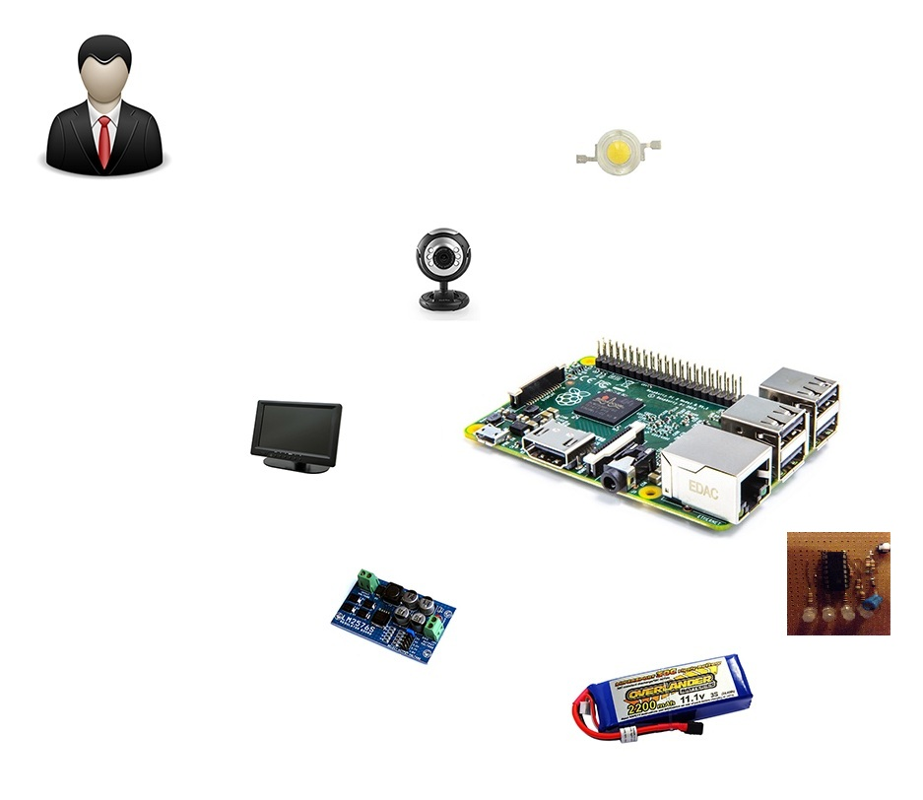

Figure 1: Components of the the system

#### Development Environment

##### Hardware requirements

* + - 4 laptops is used for development the system. These are setup Ubuntu 14.04 operating system.
    - Raspberry Pi B2 is used to process as central processing unit.
    - Cable is connection between laptop and raspberry pi 2.
    - Keyboard, mouse, and usb wifi are used to setup operating system and necessary environments for raspberry pi 2.
    - Backup flash memory: a backup solution when problems with operating system. This memory must be setup similar to main flash memory.
    - LIPO battery (12V – 3A): power for the system can works.
    - Camera module of raspberry kit: is used to capture images.
    - LCD 7 inch is used to show the interface of functions and the recognized results.
    - 2 Led (1W): is used to balance light.
    - LM2576ADJ-Board: UNI Regulator Board.
    - LT084 + zener 5.1v is used to monitor battery capacity.
    - XL6009 DC-DC Voltage Boost Module is used for increasing voltage.

##### Software requirements

* + - Operating system and platform for deployment and development: Ubuntu 14.04 for laptop and Raspbian for Raspberry PI.
    - Remote Desktop: application for remoting to work on raspberry.
    - QT 5.4 Creator: is to develop C++ application and Linux GUI.
    - OpenCV 2.4.9 library: supporting image processing.
    - SQLite 3: software creates and manages the system database.
    - Software Ideas Modeler: application for creating models and diagrams.
    - Microsoft Office 2010: is used to write documents and assign tasks.
    - Githup and TortoiseSVN and Rabbit VCS: used for source control
    - Skype: used for communication and meeting

## Project organization

### Software Process Model

#### Overall Description

Scrum is an agile methodology that can be applied to nearly any project; however, the Scrum methodology is most commonly used in software development. The Scrum process is suited for projects with rapidly changing or highly emergent requirements. Scrum software development progresses via a series of iterations called sprints, which last from one to four weeks. In the agile Scrum world, a sprint planning meeting is described in terms of the desired outcome (a commitment to a set of features to be developed in the next sprint) instead of a set of Entry criteria, Task definitions, Validation criteria, Exit criteria. The Scrum model suggests each sprint begins with a brief planning meeting and concludes with a review. These are the basics of Scrum project management.

#### Scrum Development Model

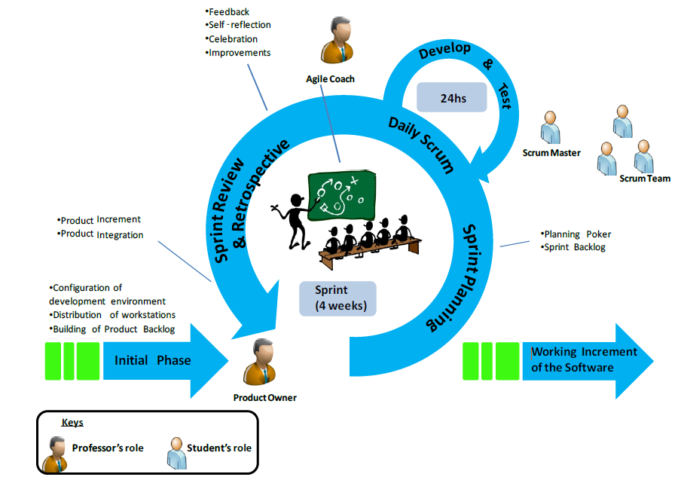

Figure 2 : Scrum Development Model

#### Reasons for Choosing

Project is developed under scrum model. We choose this model because the scope of the project is not fixed when the requirement changes day by day. Products are created quickly. Therefore, the development team can easy to change if the wrong direction. Degree of cooperation between the members is set to high.

### Roles and responsibilities

|  |  |  |  |
| --- | --- | --- | --- |
| No | Full name | Role in Group | Responsibilities |
| 1 | Đỗ Đức Minh Quân | Scrum Master/Product Owner | * Defining user requirements * Specifying business * Control the development process * Give advices on techniques, solutions and business analysis support |
| 2 | Nguyễn Hữu Kỳ Long | Team Leader, BA, DEV, Tester | * Managing process * Clarifying requirements * Researching solutions and techniques * Assigning task for members * Reviewing the result of task of members. * Editing documents and reports * Reviewing documents and reports * Developing the system software * Reviewing the system hardware * Coding * Creating test plan. * Testing |
| 3 | Nguyễn Đình Tân | Team Member, BA, DEV, Tester | * Clarifying requirements * Researching solutions and techniques * Designing database * Preparing documents and reports * Reviewing documents and reports * Developing the system software * Reviewing the system hardware * Coding * Testing |
| 4 | Lê Phương Bình | Team Member, BA, DEV, Tester | * Clarifying requirements * Preparing documents and reports * Reviewing documents and reports * Developing the system hardware * Reviewing the system software * Coding * Testing |
| 5 | Nguyễn Xuân Ý | Team Member, BA, DEV, Tester | * Clarifying requirements * Editing documents and reports * Reviewing documents and reports * Developing the system hardware * Coding * Testing |

Table 2: Roles and Responsibilities Details

### Tools and Techniques

* + - Front-end and back-end IDE:
* QT 5.4 Creator
  + - Front-end technology:
* QT 5.4 Linux GUI
  + - Back-end library:
* OPENCV 2.4.9 library
* LIBSVM 3.20 library
* Espeak 1.48.04 library
  + - Managing database:
* SQLite 3
  + - Connecting to Raspberry PI 2:
* Remote Desktop Connection Program of Ubuntu 14.04
  + - Managing the project:
* SVNtortoise version 1.8.11
* Rabbit VCS
  + - Managing documents, reports, models and diagrams:
* Software Ideas Modeler version 7.70.5385.38708
* Microsoft Office 2010

## Project Management Plan



### Product Backlog

|  |  |  |  |  |  |  |
| --- | --- | --- | --- | --- | --- | --- |
| **ID** | **Theme** | **User Type** | **Wants to...** | **So that...** | **Priority** | **Sprint** |
| 1 | Detection | User | keep track their hand gesture | can see his/her hand in the screen | Very High | 1 |
| 2 | Device | User | the system is a portable system | move the device easily and use it more flexibly | High | 1 |
| 3 | Recognition | User | recognize the hand signs | express the same meaning to the partner can understand | Very High | 2 |
| 4 | Recognition | User | receive the recognition result via text and sound | express the translated content in a clearly way | High | 2 |
| 5 | Detection | User | control the system functions by hand gesture | perform and move beetween the system functions | High | 3 |
| 6 | Power | User | know remaining of battery capacity | can monitor the use of device | Medium | 3 |
| 7 | Recognition | User | increase the accuracy of the recognition result | raise the reliability of the translated content | Very High | 4 |
| 8 | Learning | User | learn the hand sign language | learn new signs or pratice his/her signs | Medium | 4 |
| 9 | Device | User | turn on/off the system | can turn on/off the device according to the demand | Medium | 4 |

Table 3: Product Backlog Details

### Sprint Backlog

|  |  |  |  |  |  |  |  |  |  |  |  |  |  |  |  |  |  |  |  |  |
| --- | --- | --- | --- | --- | --- | --- | --- | --- | --- | --- | --- | --- | --- | --- | --- | --- | --- | --- | --- | --- |
| **Sprint** | **User Story** | **Time (est)** | **Time (spent)** | **Time (left)** | **Task** | **Time (est)** | **Who's working** | **Status** | **Work Done per week per task [Days]** | | | | | | | | | | | |
|  | *Project Name: "Vietnamese Language Sign Recognition" Started: 12-05-2015* | | | | | | | | **1** | **2** | **3** | **4** | **5** | **6** | **7** | **8** | **9** | **10** | **11** | **12** |
| 1 | As a user, I want to keep track my hand gesture | 15 | 15 | 0 | Setup development environment for Raspberry PI and laptops | **3** | All Team | Done | 3 |  |  |  |  |  |  |  |  |  |  |  |
| Capturing images from camera and showing them to user | **4** | TanND | Done | 1 | 3 |  |  |  |  |  |  |  |  |  |  |
| Extracting background color | **4** | LongNHK | Done | 1 | 3 |  |  |  |  |  |  |  |  |  |  |
| Extracting hand color | **4** | LongNHK | Done |  | 2 | 2 |  |  |  |  |  |  |  |  |  |
| Subtracting color to get hand binary image | **4** | LongNHK | Done |  |  |  | 1 |  |  |  |  |  |  |  |  |
| Finding the hand contours on the hand binary image | **4** | TanND | Done |  | 2 | 2 |  |  |  |  |  |  |  |  |  |
| Designing QT Linux GUI | **4** | TanND | Done |  |  | 3 | 1 |  |  |  |  |  |  |  |  |
| As a user, I want the system is a portable system | 15 | 15 | 0 | Choose type of battery | **3** | YNX | Done | 1 | 2 |  |  |  |  |  |  |  |  |  |  |
| Choose voltage regulator circuit | **3** | BinhLP | Done | 1 | 2 |  |  |  |  |  |  |  |  |  |  |
| Connecting components | **5** | BinhLP + YNX | Done |  | 3 | 2 |  |  |  |  |  |  |  |  |  |
| Adjusting the device components | **4** | BinhLP + YNX | Done |  |  | 3 | 1 |  |  |  |  |  |  |  |  |
| 2 | As a user, I want to recognize the hand signs | 13 | 13 | 0 | Creating SQLite database | **2** | TanND | Done |  |  |  | 2 |  |  |  |  |  |  |  |  |
| Training SVM | **3** | LongNHK | Done |  |  |  | 3 |  |  |  |  |  |  |  |  |
| Defining features to recognize | **3** | LongNHK | Done |  |  |  | 1 | 2 |  |  |  |  |  |  |  |
| Features extraction | **4** | LongNHK | Done |  |  |  |  | 3 | 1 |  |  |  |  |  |  |
| Recognizing the hand sign by SVM | **3** | LongNHK | Done |  |  |  |  |  | 3 |  |  |  |  |  |  |
| Defining the meaning word of the SVM result from database | **3** | TanND + YNX | Done |  |  |  | 2 | 1 |  |  |  |  |  |  |  |
| Designing QT Linux GUI | **4** | BinhLP + YNX | Done |  |  |  | 4 |  |  |  |  |  |  |  |  |
| As a user, I want to receive the recognition result via text and sound | 10 | 10 | 0 | Choosing text to speech opensource | **3** | TanND + BinhLP | Done |  |  |  |  | 3 |  |  |  |  |  |  |  |
| Implementing text to speech opensource | **3** | TanND + BinhLP | Done |  |  |  |  | 1 | 2 |  |  |  |  |  |  |
| Changing pronunciation of word | **4** | TanND + YNX | Done |  |  |  |  |  | 3 | 1 |  |  |  |  |  |
| Showing the recognition result via text | **2** | LongNHK | Done |  |  |  |  |  | 1 | 1 |  |  |  |  |  |
| Showing the recognition result via sound | **4** | BinhLP + YNX | Done |  |  |  |  |  | 3 | 1 |  |  |  |  |  |
| 3 | As a user, I want to control the system functions by hand gesture | 15 | 15 | 0 | Defining operations of function | **3** | LongNHK + TanND | Done |  |  |  |  |  |  | 3 |  |  |  |  |  |
| Implementing operations of function | **3** | LongNHK + TanND | Done |  |  |  |  |  |  | 1 | 2 |  |  |  |  |
| Designing QT Linux GUI | **4** | LongNHK + TanND | Done |  |  |  |  |  |  |  | 3 | 1 |  |  |  |
| Synchronize between hand gestures and operations of function | **5** | LongNHK + TanND | Done |  |  |  |  |  |  |  |  | 4 | 1 |  |  |
| As a user, I want to know remaining of battery capacity | 15 | 15 | 0 | Choosing chip voltage comparator | **3** | BinhLP + YNX | Done |  |  |  |  |  |  | 3 |  |  |  |  |  |
| Choosing zener | **3** | BinhLP + YNX | Done |  |  |  |  |  |  | 1 | 2 |  |  |  |  |
| Constructing circuit | **4** | BinhLP + YNX | Done |  |  |  |  |  |  |  | 3 | 1 |  |  |  |
| Adjusting the device components | **2** | BinhLP + YNX | Done |  |  |  |  |  |  |  |  | 2 |  |  |  |
| Connecting to the system | **3** | BinhLP + YNX | Done |  |  |  |  |  |  |  |  | 2 | 1 |  |  |
| 4 | As a user, I want to increase the accuracy of the recognition result | 11 | 11 | 0 | Defining more features to recognize | **3** | All Team | Done |  |  |  |  |  |  |  |  |  | 3 |  |  |
| Extracting features | **3** | LongNHK | Done |  |  |  |  |  |  |  |  |  | 1 | 2 |  |
| Providing two LEDs to balance light | 3 | BinhLP + YNX | Done |  |  |  |  |  |  |  |  |  | 1 | 2 |  |
| Improving camera setting | 2 | TanND + YNX | Done |  |  |  |  |  |  |  |  |  | 1 | 1 |  |
| Improving background - hand color subtraction | 2 | LongNHK + TanND | Done |  |  |  |  |  |  |  |  |  |  | 3 |  |
| Training SVM | **3** | LongNHK | Done |  |  |  |  |  |  |  |  |  |  |  | 2 |
| As a user, I want to learn hand sign language | 8 | 8 | 0 | Creating database | **2** | TanND | Done |  |  |  |  |  |  |  |  |  |  | 1 |  |
| Managing database | **2** | TanND | Done |  |  |  |  |  |  |  |  |  |  |  | 2 |
| Implementing the practice function of learning | **4** | LongNHK + BinhLP | Done |  |  |  |  |  |  |  |  |  |  |  | 4 |
| Designing GUI | **4** | TanND + YNX | Done |  |  |  |  |  |  |  |  |  |  |  | 4 |
| As a user, I want to turn on/off the system | 8 | 8 | 0 | Choosing switch button | **2** | BinhLP | Done |  |  |  |  |  |  |  |  |  |  | 2 |  |
| Constructing circuit | **3** | BinhLP + YNX | Done |  |  |  |  |  |  |  |  |  |  |  | 3 |
| Connecting to the system | **3** | BinhLP | Done |  |  |  |  |  |  |  |  |  |  |  | 3 |
|  | TOTAL | 60 | 60 | 0 |  |  |  |  | 5 | 5 | 5 | 5 | 5 | 5 | 5 | 5 | 5 | 5 | 5 | 5 |
|  | Daily burnout | 0 |  |  |  |  |  |  | **5** | **5** | **5** | **5** | **5** | **5** | **5** | **5** | **5** | **5** | **5** | **5** |
|  | **Total time left (from estimate)** |  |  |  |  |  | Estimate | 60 | 55 | 50 | 45 | 40 | 35 | 30 | 25 | 20 | 15 | 10 | 5 | 0 |
|  | **Total time left (from spent)** |  |  |  |  |  | Burnout | 60 | 55 | 50 | 45 | 40 | 35 | 30 | 25 | 20 | 15 | 10 | 5 | 0 |
|  |  |  |  |  |  |  |  |  |  |  |  |  |  |  |  |  |  |  |  |  |

Table 4: Sprint Backlog Details



### Sprint Burndown Chart

Figure 3: Chart of Sprint Backlog

### All Meeting Minutes

|  |  |
| --- | --- |
| **Name** | **Definition** |
| x | Selected Person |
| VH | Very High Priority |
| H | High Priority |
| M | Medium Priority |
| A | Approved |
| Y | Yes |
| N | No |

Table 5: Definitions, Acronyms, and Abbreviations

|  |  |  |  |  |  |  |  |  |  |  |  |  |
| --- | --- | --- | --- | --- | --- | --- | --- | --- | --- | --- | --- | --- |
| **Scrum Meeting Minutes** | | | | | Target Personas | | | | Status | | Approval | |
| LongNHK | TanND | BinhLP | YNX | Degree of priority | Task completion | LongNHK | Mr. QuanDDM |
|
|
|
|
|
| **Date: 12/05/2015** | | | | |  | | | |  | |  | |
| *Raspberry PI 2* | | | | |  | | | |  | |  |  |
| Development environment for Raspberry | | | | | x | x | x | x | H | Y | A | A |
| *Report 1* | | | | |  | | | |  | | | |
| Orienting the way writing report 1 | | | | | x | x | x | x | VH | Y | A | A |
| **Date: 16/05/2015** | | | | |  | | | |  | |  | |
| *Hand Detection* | | | | |  | | | |  | |  |  |
| Extracting background color | | | | | x |  |  |  | VH | Y | A | A |
| Capturing images from camera and showing them to user | | | | |  | x |  |  | VH | Y | A | A |
| *Portable System* | | | | |  | | | |  | |  |  |
| Choosing type of battery | | | | |  |  |  | x | H | Y | A | A |
| Choosing voltage regulator circuit | | | | |  |  | x |  | H | Y | A | A |
| *Report 1* | | | | |  | | | |  | | | |
| Reviewing report 1 | | | | | x | x | x | x | H | Y | A | A |
| **Date: 19/05/2015** | | | | |  | | | |  | | | |
| *Hand Detection* | | | | |  | | | |  | |  |  |
| Demo extracting background color | | | | | x |  |  |  | H | Y | A | A |
| Demo capturing images from camera and showing them to user | | | | |  | x |  |  | H | Y | A | A |
| *Portable System* | | | | |  | | | |  | |  |  |
| Reviewing battery | | | | | x | x | x | x | M | Y | A | A |
| Reviewing voltage regulator circuit | | |  |  | x | x | x | x | M | Y | A | A |
| *Report 2* | | | | |  | | | |  | | | |
| Orienting the way writing report 2 | | | | | x | x | x | x | VH | Y | A | A |
| **Date: 23/05/2015** | | | | |  | | | |  | | | |
| *Hand Detection* | | | | |  | | | |  | |  |  |
| Extracting hand color | | | | | x |  |  |  | VH | Y | A | A |
| Finding the hand contours on the hand binary image | | | | |  | x |  |  | VH | Y | A | A |
| *Portable System* | | | | |  | | | |  | |  |  |
| Connecting components | | | | |  |  | x | x | H | Y | A | A |
| *Report 2* | | | | |  | | | |  | | | |
| Reviewing report 2 | | | | | x | x | x | x | H | Y | A | A |
| **Date: 26/05/2015** | | | | |  | | | |  | | | |
| *Hand Detection* | | | | |  | | | |  | |  |  |
| Extracting hand color | | | | | x |  |  |  | H | Y | A | A |
| Designing QT Linux GUI which of subtracting color | | | | |  | x |  |  | H | Y | A | A |
| *Portable System* | | | | |  | | | |  | |  |  |
| Demo fully made portable system | | |  |  |  |  | x | x | H | Y | A | A |
| *Report 3* | | | | |  | | | |  | | | |
| Orienting the way writing report 3 | | | | | X | x | x | x | VH | Y | A | A |
| **Date: 30/05/2015** | | | | |  | | | |  | | | |
| *Hand Detection* | | | | |  | | | |  | |  |  |
| Subtracting color to get hand binary image | | | | | x |  |  |  | VH | Y | A | A |
| Finding the hand contours on the hand binary image | | | | |  | x |  |  | VH | Y | A | A |
| *Portable System* | | | | |  | | | |  | |  |  |
| Demo adjusted portable system | | | | |  |  | x | x | M | Y | A | A |
| *Report 3* | | | | |  | | | |  | | | |
| Orienting the way writing report 3 | | | | | x | x | x | x | VH | Y | A | A |
| **Date: 02/06/2015** | | | | |  | | | |  | | | |
| *Hand Detection* | | | | |  | | | |  | |  |  |
| Training SVM | | | | | x |  |  |  | VH | Y | A | A |
| Creating SQLite database | | |  |  |  | x |  |  | VH | Y | A | A |
| Designing QT Linux GUI which of steps recognition | | | | |  |  | x | x | M | Y | A | A |
| *Report 3* | | | | |  | | | |  | | | |
| Reviewing report 3 | | | | | x | x | x | x | VH | Y | A | A |
| **Date: 06/06/2015** | | | | |  | | | |  | | | |
| *Hand Detection* | | | | |  | | | |  | |  |  |
| Defining features to recognize | | | | | x |  |  |  | VH | Y | A | A |
| Defining the meaning word of the SVM result from database | | | | |  | x |  |  | VH | Y | A | A |
| *Portable System* | | | | |  | | | |  | |  |  |
| Designing QT Linux GUI which of the recognition flow | | | | |  |  | x | x | M | Y | A | A |
| *Report 3* | | | | |  | | | |  | | | |
| Reviewing report 3 | | | | | x | x | x | x | VH | Y | A | A |
| **Date: 09/06/2015** | | | | |  | | | |  | | | |
| *Hand Detection* | | | | |  | | | |  | |  |  |
| Defining features to recognize | | | | | x |  |  |  | VH | Y | A | A |
| Defining the meaning word of the SVM result from database | | | | |  |  |  | x | M | Y | A | A |
| *Result via sound* | | | | |  | | | |  | |  |  |
| Choosing text to speech opensource | | | |  |  | x | x |  | H | Y | A | A |
| *Report 4* | | | | |  | | | |  | | | |
| Orienting the way writing report 4 | | | | | x | x | x | x | VH | Y | A | A |
| **Date: 13/06/2015** | | | | |  | | | |  | | | |
| *Hand Detection* | | | | |  | | | |  | |  |  |
| Features extraction | | | | | x |  |  |  | VH | Y | A | A |
| *Result via sound* | | | | |  | | | |  | |  |  |
| Changing pronunciation of word | | | | |  | x |  | x | H | Y | A | A |
| Implementing text to speech opensource | | | |  |  | x | x |  | M | Y | A | A |
| *Report 4* | | | | |  | | | |  | | | |
| Orienting the way writing report 4 | | | | | x | x | x | x | VH | Y | A | A |
| **Date: 16/06/2015** | | | | |  | | | |  | | | |
| *Hand Detection* | | | | |  | | | |  | |  |  |
| Recognizing the hand sign by SVM | | | | | x |  |  |  | VH | Y | A | A |
| *Result via sound* | | | | |  | | | |  | |  |  |
| Changing pronunciation of word | | | | |  | x |  | x | H | Y | A | A |
| Showing the recognition result via sound | | | |  |  |  | x |  | M | Y | A | A |
| *Report 4* | | | | |  | | | |  | | | |
| Reviewing report 4 | | | | | x | x | x | x | VH | Y | A | A |
| **Date: 20/06/2015** | | | | |  | | | |  | | | |
| *Hand Detection* | | | | |  | | | |  | |  |  |
| Showing the recognition result via text | | | | | x |  |  |  | H | Y | A | A |
| *Result via sound* | | | | |  | | | |  | |  |  |
| Changing pronunciation of word | | | | |  |  |  | x | H | Y | A | A |
| Showing the recognition result via sound | | | |  |  |  | x |  | M | Y | A | A |
| *Report 4* | | | | |  | | | |  | | | |
| Reviewing report 4 | | | | | x | x | x | x | H | Y | A | A |
| **Date: 30/06/2015** | | | | |  | | | |  | | | |
| *Controlling function* | | | | |  | | | |  | |  |  |
| Defining operations of function | | | | | x | x |  |  | VH | Y | A | A |
| *Monitor the battery capacity* | | | | |  | | | |  | |  |  |
| Choosing chip voltage comparator | | | | |  |  | x | x | H | Y | A | A |
| *Report 5* | | | | |  | | | |  | | | |
| Orienting the way writing report 5 | | | | | x | x | x | x | VH | Y | A | A |
| **Date: 04/07/2015** | | | | |  | | | |  | | | |
| *Controlling function* | | | | |  | | | |  | |  |  |
| Implementing operations of function | | | | | x | x |  |  | VH | Y | A | A |
| *Monitor the battery capacity* | | | | |  | | | |  | |  |  |
| Choosing zener | | | | |  |  | x | x | H | Y | A | A |
| *Report 5* | | | | |  | | | |  | | | |
| Orienting the way writing report 5 | | | | | x | x | x | x | VH | Y | A | A |
| **Date: 07/07/2015** | | | | |  | | | |  | | | |
| *Controlling function* | | | | |  | | | |  | |  |  |
| Demo implementing operations of function | | | | | x | x |  |  | H | Y | A | A |
| *Monitor the battery capacity* | | | | |  | | | |  | |  |  |
| Reviewing the chip voltage comparator and zener | | | | | x | x | x | x | VH | Y | A | A |
| *Report 5* | | | | |  | | | |  | | | |
| Orienting the way writing report 5 | | | | | x | x | x | x | VH | Y | A | A |
| **Date: 11/07/2015** | | | | |  | | | |  | | | |
| *Controlling function* | | | | |  | | | |  | |  |  |
| Designing QT Linux GUI which of the flow of operations | | | | | x | x |  |  | H | Y | A | A |
| *Monitor the battery capacity* | | | | |  | | | |  | |  |  |
| Constructing circuit | | | | |  |  | x | x | VH | Y | A | A |
| *Report 5* | | | | |  | | | |  | | | |
| Reviewing report 5 | | | | | x | x | x | x | VH | Y | A | A |
| **Date: 14/07/2015** | | | | |  | | | |  | | | |
| *Controlling function* | | | | |  | | | |  | |  |  |
| Synchronizing between hand gestures and operations of function | | | | | x | x |  |  | VH | Y | A | A |
| *Monitor the battery capacity* | | | | |  | | | |  | |  |  |
| Adjusting the device components | | | | |  |  | x | x | H | Y | A | A |
| *Report 5* | | | | |  | | | |  | | | |
| Reviewing report 5 | | | | | x | x | x | x | VH | Y | A | A |
| **Date: 18/07/2015** | | | | |  | | | |  | | | |
| *Controlling function* | | | | |  | | | |  | |  |  |
| Demo synchronizing between hand gestures and operations of function | | | | | x | x |  |  | M | Y | A | A |
| *Portable System* | | | | |  | | | |  | |  |  |
| Connecting to the system | | | | |  |  | x | x | VH | Y | A | A |
| *Report 5* | | | | |  | | | |  | | | |
| Reviewing report 5 | | | | | x | x | x | x | VH | Y | A | A |
| **Date: 21/07/2015** | | | | |  | | | |  | | | |
| *Hand Detection* | | | | |  | | | |  | |  |  |
| Defining more features to recognize | | | | | x | x | x | x | VH | Y | A | A |
| *Report 5* | | | | |  | | | |  | | | |
| Reviewing report 5 | | | | | x | x | x | x | H | Y | A | A |
| **Date: 25/07/2015** | | | | |  | | | |  | | | |
| *Hand Detection* | | | | |  | | | |  | |  |  |
| Extracting features | | | | | x |  |  |  | VH | Y | A | A |
| Improving camera setting | | |  |  |  | x |  | x | M | Y | A | A |
| *Stable Environment* | | | | |  | | | |  | |  |  |
| Providing two LEDs to balance light | | | | |  |  | x | x | H | Y | A | A |
| *Report 5* | | | | |  | | | |  | | | |
| Reviewing report 5 | | | | | x | x | x | x | H | Y | A | A |
| **Date: 28/07/2015** | | | | |  | | | |  | | | |
| *Hand Detection* | | | | |  | | | |  | |  |  |
| Demo extracting features | | | | | x |  |  |  | H | Y | A | A |
| Improving background - hand color subtraction | | | | | x | x |  |  | VH | Y | A | A |
| Demo improving camera setting | | | | |  | x |  | x | M | Y | A | A |
| *Stable Environment* | | | | |  | | | |  | |  |  |
| Demo balancing light | |  |  |  |  |  | x | x | M | Y | A | A |
| *Report 6* | | | | |  | | | |  | | | |
| Orienting the way writing report 6 | | | | | x | x | x | x | VH | Y | A | A |
| **Date: 01/08/2015** | | | | |  | | | |  | | | |
| *Hand Detection* | | | | |  | | | |  | |  |  |
| Improving background - hand color subtraction | | | | | x | x |  |  | H | Y | A | A |
| *Learning Function* | | | | |  | | | |  | |  |  |
| Creating database | |  |  |  |  | x |  |  | H | Y | A | A |
| Designing GUI | | | | |  | x |  | x | M | Y | A | A |
| Implementing the practice function of learning | | | | | x |  | x |  | M | Y | A | A |
| *Report 6* | | | | |  | | | |  | | | |
| Orienting the way writing report 6 | | | | | x | x | x | x | VH | Y | A | A |
| **Date: 04/08/2015** | | | | |  | | | |  | | | |
| *Hand Detection* | | | | |  | | | |  | |  |  |
| Training SVM | | | | | x |  |  |  | VH | Y | A | A |
| *Learning Function* | | | | |  | | | |  | |  |  |
| Managing database | |  |  |  |  | x |  |  | M | Y | A | A |
| Designing GUI | | | | |  | x |  | x | H | Y | A | A |
| *ON/OFF the system* | | | | |  | | | |  | |  |  |
| Choosing switch button | |  |  |  |  |  | x |  | H | Y | A | A |
| *Report 6* | | | | |  | | | |  | | | |
| Orienting the way writing report 6 | | | | | x | x | x | x | VH | Y | A | A |
| **Date: 08/08/2015** | | | | |  | | | |  | | | |
| *Learning Function* | | | | |  | | | |  | |  |  |
| Implementing the practice function of learning | | | | | x |  | x |  | VH | Y | A | A |
| Demo GUI |  |  |  |  |  | x |  | x | H | Y | A | A |
| *ON/OFF the system* | | | | |  | | | |  | |  |  |
| Constructing circuit | | | | |  |  | x | x | VH | Y | A | A |
| *Report 6* | | | | |  | | | |  | | | |
| Reviewing report 6 | | | | | x | x | x | x | VH | Y | A | A |
| **Date: 11/08/2015** | | | | |  | | | |  | | | |
| *Learning Function* | | | | |  | | | |  | |  |  |
| Demo learning function | | | | | x |  | x |  | H | Y | A | A |
| Demo GUI |  |  |  |  |  | x |  | x | M | Y | A | A |
| *ON/OFF the system* | | | | |  | | | |  | |  |  |
| Demo constructed circuit | | | | |  |  | x | x | H | Y | A | A |
| Connecting to the system | | |  |  |  |  | x | x | VH | Y | A | A |
| *Report 6* | | | | |  | | | |  | | | |
| Reviewing report 6 | | | | | x | x | x | x | VH | Y | A | A |

Table 6: Scrum Meeting Minutes Detail

## Coding Convention

*General view of C++ Programming Style put into practice in the project*

* Naming Conventions
* Variable names must be in mixed case starting with lower case.
* Named constants must be all uppercase using underscore to separate words.
* Names representing methods or functions must be verbs and written in mixed case starting with lower case.
* Plural form should be used on names representing a collection of objects
* The prefix is should be used for Boolean variables and methods
* Include Files and Include Statements
* Header files must contain an include guard
* Include statements should be sorted and grouped
* Include statements must be located at the top of a file only
* Variables
* Class variables should never be declared public
* C++ pointers and references should have their reference symbol next to the type rather than to the name
* Conditionals
* Complex conditional expressions must be avoided
* The conditional should be put on a separate line
* Executable statements in conditionals must be avoided
* Comments
* Use // for all comments, including multi-line comments
* Comments should be included relative to their position in the code
* Class and method header comments should follow the JavaDoc conventions

*References*

C++ Programming Style Guidelines, Version 4.9, January 2011, Geotechnical Software Services, Copyright © 1996 – 2011

<http://geosoft.no/development/cppstyle.html>

# Report No. 3 Software Requirement Specification

## User Requirement Specification

*The system is not only reserved for mute person but also everyone who wants to learn sign language. Therefore, we have determined the requirement from these users:*

* Recognize his or her hand signs to text and sound: users want devices that can recognize exactly their hand signs. Then, the device must show recognition results via text on screen and emit pronunciation of this word via speaker.
* Learn the way expressing hand signs: there still are a lot of hand signs that users do not know exactly, they want a device that can help them practice these signs. The system should have images which can describe clearly the way expressing hand sign for user can follow. In addition, the system should have practice function for user practice.
* Controlling the system by hand gesture: users want to perform the operations of the system through his or her hand gesture without electricity devices.
* The system is portable: Users can easily move the system. They expect the system can work at many places, and it still works during a power outage.
* System's power must be controlled: Users can know the remaining battery capacity to monitor the use of equipment. Moreover, they can charge the battery when the battery is low.
* System should be easy to use as the electricity systems people use in daily live: Users can turn on/off the system safely without prejudice to the durability of the equipment.

## System Requirement Specification

### External Interface Requirement

External interface is concerned with designing interactive products to support the way people communicate and interact in their everyday and working lives. The products must be usability means easy to learn, effective to use and provide an enjoyable experience.

#### User Interface

* The GUI should be simple, clear, intuitive, and reminiscent.
* The interface is accessible, easy to use, and efficient.
* The interface should meet some criteria such as direct manipulation, device actions, information processing approach, visual features, …
* Each screen has fully instructions of the function implementation. Besides that, it still provides error, success, or implementation notification.

#### Hardware Interface

* The system must design hardware interface similar to the standard electricity system for anyone can use.
* Provide fully devices of a portable system.
* The system needs to be designed suitable for capturing the hands with an appropriate height, and a width for people can watch the LCD.
* The provided devices should be easy to replace.
* Electricity devices should be packaged in the safety way.

#### Software Interface

* Linux GUI for Raspbian Operating System.
* The interface must be responsive for LCD 7-inch with the resolution 1024 * 600.

### System Overview Use Case

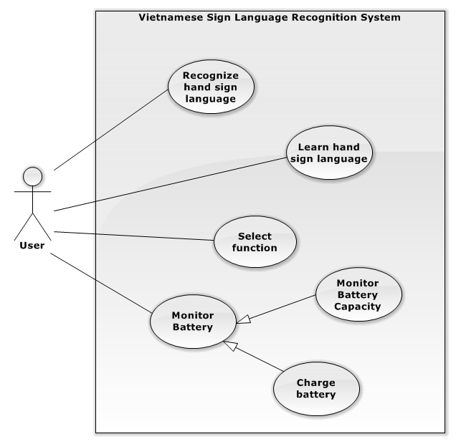

Figure 4: System Overview Use Case



### List of Use Case

#### Select Function

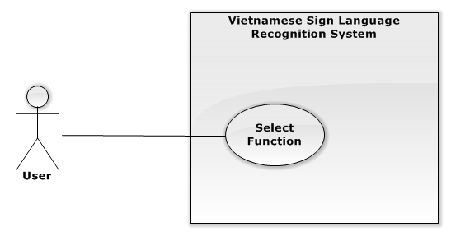

Figure 5: Select Function use case diagram

**Use Case Specification**

|  |  |  |  |  |  |
| --- | --- | --- | --- | --- | --- |
| **USE CASE -1 SPECIFICATION** | | | | | |
| **Use-case No.** | VSLR001 | **Use-case Version** | | | 1.0 |
| **Use-case Name** | Select Function | | | | |
| **Author** | Nguyễn Hữu Kỳ Long | | | | |
| **Date** | 31/05/2015 | | **Priority** | High | |
| **Actor**   * User   **Summary**   * The use case describes the way selecting the system functions.   **Goal**   * Select the desired function by the hand gesture.   **Triggers**   * User turns on the system or back from the function implementation interfaces.   **Preconditions**   * Background Color Subtraction succeeds.   **Post Conditions**   * **On Success**: The selected function interface will show.   **Main Success Scenario**   |  |  |  | | --- | --- | --- | | Step | Actor Action | System Response | | 1 | N/A | - The images containing only the hand on the black background that shows continuously.  - These images must contain 2 rectangle areas inside, one has the sentences “Nhận dạng ngôn ngữ người câm” and another has the sentences “Học ngôn ngữ người câm”.  - The system shows notifications “Hãy chọn chức năng mong muốn bằng cách đưa ký hiệu hình bên vào vùng chức năng đó”. | | 2 | Move the “select” hand sign into the desired function rectangle area. | - The selected function rectangle area changes color to red color. | | 3 | Change the “select” hand sign into “done” hand sign.  [Alternative No.1]  [Alternative No.2]  [Alternative No.3] | - The selected function interface is displayed. |   **Alternative Scenario**   |  |  |  | | --- | --- | --- | | No | Actor Action | System Response | | 1 | User shows the hand signs differently from “select” and “done” hand sign. | - The two function rectangle areas back to white color. | | 2 | Move the hand outside the two function rectangle areas. | - The two function rectangle areas back to white color. | | 3 | Move the “select” hand sign into the remaining function rectangle area. | - The selected function rectangle area changes color to red color.  - The remaining function rectangle area backs to white color. |   **Exceptions**   |  |  |  | | --- | --- | --- | | No | Actor Action | System Response | |  |  |  |   **Relationships**   * N/A   **Business Rules**   * N/A | | | | | |

#### Recognize Hand Sign Language

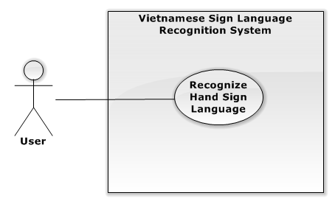

Figure 6: Recognize Hand Sign Language use case diagram

**Use Case Specification**

|  |  |  |  |  |  |
| --- | --- | --- | --- | --- | --- |
| **USE CASE -2 SPECIFICATION** | | | | | |
| **Use-case No.** | VSLR001 | **Use-case Version** | | | 1.0 |
| **Use-case Name** | Recognize Hand Sign Language | | | | |
| **Author** | Nguyễn Hữu Kỳ Long | | | | |
| **Date** | 31/05/2015 | | **Priority** | High | |
| **Actor**   * User   **Summary**   * The use case describes the way recognizing hand signs captured by camera.   **Goal**   * Recognize hand signs and translate them to the same meaning content with the kind of sound and text.   **Triggers**   * User shows the specific “select” hand sign on the “Recognize” function area and then shows the “done” hand sign to select “Recognize Hand Sign” function.   **Preconditions**   * The “Recognize Hand Sign” function is selected.   **Post Conditions**   * **On Success**: The translated content shows on the screen and speaker of LCD.   **Main Success Scenario**   |  |  |  | | --- | --- | --- | | Step | Actor Action | System Response | | 1 |  | - The images containing only the hand inside the black background shows continuously.  - A notify “Hệ thống sẽ lưu lại kết quả nhận dạng sau 3 giây” is shown.  - Countdown time is shown from 3. | | 2 | User shows the hand sign through camera  [Alternative No.1] | - Countdown time is counting down.  - The system shows a new notify containing the recognition result of the current hand sign. | | 3 | User waits for the counting down counts to 0. | - The entire translated content will be updated and shown on the screen under the label “Nội dung”  - The system backs to step No.1 |   **Alternative Scenario**   |  |  |  | | --- | --- | --- | | No | Actor Action | System Response | | 1 | User shows “end” hand sign. | - The system will show the whole content which was translated via text and speaker of LCD.  - After that, the system navigates to “Select Function” interfaces. |   **Exceptions**   |  |  |  | | --- | --- | --- | | No | Actor Action | System Response | |  |  |  |   **Relationships**   * N/A   **Business Rules**   * N/A | | | | | |

#### Learn Hand Sign

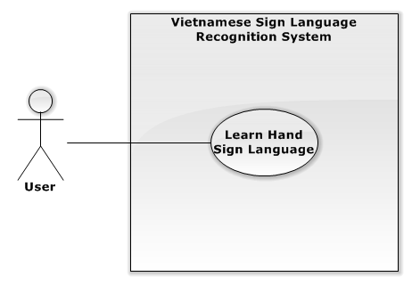

Figure 7: Learn sign use case diagram

**Use Case Specification**

|  |  |  |  |  |  |
| --- | --- | --- | --- | --- | --- |
| **USE CASE -3 SPECIFICATION** | | | | | |
| **Use-case No.** | VSLR002 | **Use-case Version** | | | 1.0 |
| **Use-case Name** | Learn Hand Sign | | | | |
| **Author** | Nguyễn Hữu Kỳ Long | | | | |
| **Date** | 31/05/2015 | | **Priority** | Medium | |
| **Actor**   * User   **Summary**   * The use case describes the way practising a hand sign.   **Goal**   * It is to help user training his or her hand gesture more accurately.   **Triggers**   * User shows the specific “select” hand sign on the “Learn Hand Sign” function area then shows the “done” hand sign to select “Learn Hand Sign” function.   **Preconditions**   * The “Learn Hand Sign” function is selected.   **Post Conditions**   * **On Success**: The system shows the image describing the selected word and mean of the hand sign which is captured.   **Main Success Scenario:**   |  |  |  | | --- | --- | --- | | Step | Actor Action | System Response | | 1 |  | - The system shows the list of words supported in the syste and the “A” word is selected first.  - Image describing “A” hand sign is displayed.  - The images containing only the hand on the black background shows continuously.  - These images contain two white square areas, one has “Up” arrow inside and the remaining has “Down” arrow inside.  - A notify “Hãy đưa kí hiệu trong hướng dẫn vào vùng mũi tên lên xuống để thay đổi từ được chọn ” is shown. | | 2 | User shows the specific “select” hand sign through camera on the “up” or “down” function square area. | - The selected function square area changes color to red color. | | 3 | User changes to the “done” hand sign.  [Alternative No.1]  [Alternative No.2]  [Alternative No.3] | - The system moves the selection to upper or lower word in the list of words.  - The system shows the images describing the hand gesture of the selected word. | | 4 | User shows the hand gesture through camera.  [Alternative No.4] | - The system returns the recognition result on text. |   **Alternative Scenario**   |  |  |  | | --- | --- | --- | | No | Actor Action | System Response | | 1 | User shows the hand signs differently from “select” and “done” hand sign. | - The two function rectangle areas back to white color. | | 2 | Move the hand outside the two function square areas. | - The two function rectangle areas back to white color. | | 3 | Move the “select” hand sign into the remaining function rectangle area. | - The selected function rectangle area changes color to red color.  - The remaining function rectangle area backs to white color. | | 4 | User shows the specific “end” hand sign through camera. | - The system navigates to the “Select Function” interface. |   **Exceptions:**   |  |  |  | | --- | --- | --- | | No | Actor Action | System Response | |  |  |  |   **Relationships**   * N/A   **Business Rules**   * N/A | | | | | |

#### Charge Battery

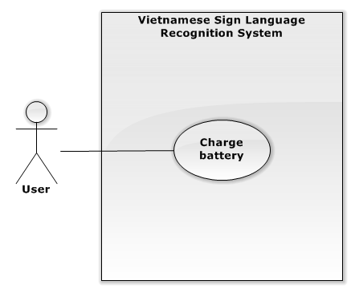

Figure 8: Learn sign use case diagram

**Use Case Specification**

|  |  |  |  |  |  |
| --- | --- | --- | --- | --- | --- |
| **USE CASE -4 SPECIFICATION** | | | | | |
| **Use-case No.** | VSLR003 | **Use-case Version** | | | 1.0 |
| **Use-case Name** | Charge Battery | | | | |
| **Author** | Lê Phương Bình | | | | |
| **Date** | 31/05/2015 | | **Priority** | High | |
| **Actor**   * User   **Summary**   * The use case describes users how to know to charge battery.   **Goal**   * It is to help the system has enough power to operate.   **Triggers**   * User receives low battery notify from the system.   **Preconditions**   * N/A   **Post Conditions**   * **On Success**: The battery charger’s LEDs will be bright.   **Main Success Scenario:**   |  |  |  | | --- | --- | --- | | Step | Actor Action | System Response | | 1 | - User connects LIPO B3AC charger to AC power source 220V. | - The charger’s LEDs indicator is bright with red color. | | 2 | - User waits for LIPO battery is charged full.  [Alternative No.1] | - Three Charger’s LEDs are bright with green color. |   **Alternative Scenario**   |  |  |  | | --- | --- | --- | | No | Actor Action | System Response | | 1 | - User interrupts LIPO B3AC charger connection to AC power source 220V. | - The charger’s LEDs indicator is dark. |   **Exceptions:**   |  |  |  | | --- | --- | --- | | No | Actor Action | System Response | |  |  |  |   **Relationships**   * N/A   **Business Rules**   * N/A | | | | | |

#### Monitor Battery Capacity

**Use Case Specification**

|  |  |  |  |  |  |
| --- | --- | --- | --- | --- | --- |
| **USE CASE - 5 SPECIFICATION** | | | | | |
| **Use-case No.** | VSLR004 | **Use-case Version** | | | 1.0 |
| **Use-case Name** | Monitor Battery Capacity | | | | |
| **Author** | Lê Phương Bình | | | | |
| **Date** | 31/05/2015 | | **Priority** | Medium | |
| **Actor**   * User   **Summary**   * The use case describes users how to know the remaining battery capacity supplying the system.   **Goal**   * It is to help user uses reasonable system.   **Triggers**   * Turn on the system.   **Preconditions**   * The system is on.   **Post Conditions**   * **On Success**: Battery capacity is shown at the battery’s LEDs showing capacity.   **Main Success Scenario:**   |  |  |  | | --- | --- | --- | | Step | Actor Action | System Response | | 1 |  | - Battery capacity display is shown by led:   * Full: Four Leds are bright * 75%: Three Leds are bright. * 50%: Two Leds are bright. * 25%: One Leds is bright. * Empty: No led is bright.   - System shows a notify “Bin yếu vui lòng tắt hệ thống và cắm sạc. Thông báo sẽ được tự động tắt.” on the system interface, when the battery capacity is uder 25%. |   **Alternative Scenario**   |  |  |  | | --- | --- | --- | | No | Actor Action | System Response | | 1 |  |  |   **Exceptions:**   |  |  |  | | --- | --- | --- | | No | Actor Action | System Response | |  |  |  |   **Relationships**   * N/A   **Business Rules**   * N/A | | | | | |

## System Attribute

### Usability

The system should be designed for everyone can use easily in controlling and GUI operations.

#### Graphic User Interface

* The system musts show all instructions, notifications and operations in Vietnamese.

#### Usability

* User just needs to read the user manual which is enclosed with the system for using in the first time. The attached manual guide must be clear. User can read and do by themselves.

#### Hardware controlling

* User can control the device very easily as well as using any electronic device in the daily live.

### Reliability

* The database should be constructed on Vietnamese sign language.
* The system uses “Support Vector Machine” library to recognize hand sign language and OpenCV library to process image.
* The system is using Raspberry PI 2 to process which is popular board in the world.

### Availability

* The system runs continuously about 3 hours with LIPO 2700mAh battery. That means it is safe to user.

### Security

N/A

### Maintainability

* Electronic devices in the system are common so when any electronic equipment, which is attached with the system, is out of ordered, it is so easy to change or to fix at any electronic store.
* The system can be extended in the future.

### Portability

* The system supplies the LIPO battery as power source in which user can use for 3 hours without charging. In addition, the system also provides LIPO B3AC charger for users.
* The system provides a circuit monitoring LIPO battery for users.

### Performance

The system uses Raspberry PI 2 with RAM 1GB as central unit processing, so that the system can recognize one hand sign in 1 to 3 seconds and hand sign recognize can be performed continuously.

# Report No.5 System Implementation & Test

## Introduction

### Overview

This section provides in detail all necessary information about implementation information and testing procedure of VSLR includes test plans, test cases, test procedures and test result.

### Test Approach

#### Method

* *Black-box testing*: We examines the functionality of the system without peering into its internal structures or workings. This testing can dominate integration testing as well.

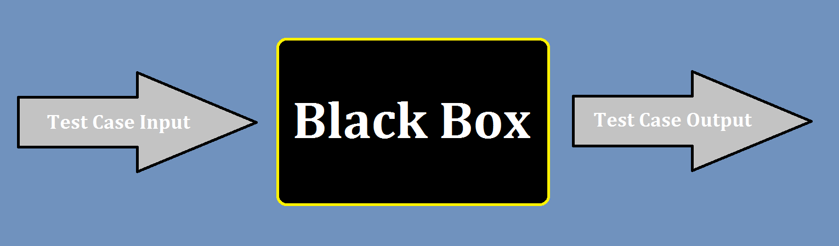

#### Goal

* To validate that the application works as the user will be operating it, then find out incorrect or missing functions, interface errors, behavior and performance errors.

## Database Relationship Diagram

### Physical Diagram

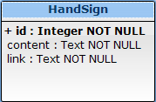

Figure 52: Physical Database Diagram

### Data Dictionary

|  |  |
| --- | --- |
| **Entity Data dictionary: describe content of all entities** | |
| **Entity Name** | **Description** |
| HandSign | Describe the hand sign words in the system. |

|  |  |  |  |  |
| --- | --- | --- | --- | --- |
| **Entity name** | **Attributes** | **Description** | **Domain** | **Null** |
| HandSign | id | Unique identifier of the hand sign. | Integer | No |
| content | The translated content of the handsign | Text | No |
| link | The image link lead to images describing the hand sign. | Text | No |

## Test Plan

### Test items

*We have a main test phase : Integration test:*

* Integration Testing: We test the integration of the code modules developed and interaction with hardware. The integration testing starts at the bottom level. Each component at lower hierarchy is tested individually; then the components that rely upon these are tested.

### Features to be tested

*Integration Test includes the following features:*

* Background Color Subtraction
* “Selecting Function” function
* “Hand Sign Language Recognition” function
* “Learning Hand Sign Language” function
* “Charging Battery” function
* “Monitoring Battery Capacity” function

### Features not to be tested

### N/A

### Environmental needs

* A complete system with fully devices and functions.
* An environment with stable light, and background is not complex in color.

### Test case pass/fail criteria

* Every test case must describe what expected output are to pass that specific test.
* Test coverage must be at least 90%.
* All test case must pass.

## 

## Integration Test Specifications

### “Background Color Subtraction” Test

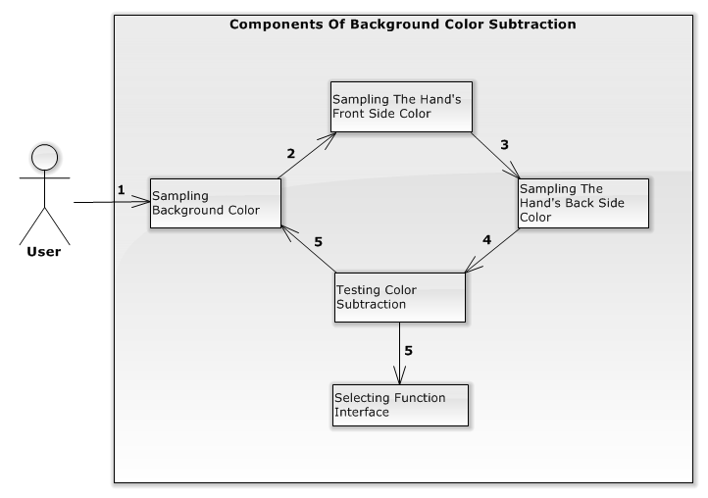

Figure 52: Components of the Background Color Subtraction

#### Integration test case

|  |  |  |  |  |
| --- | --- | --- | --- | --- |
| **ID** | **Test Item(s)** | **Input specification** | **Expected Output** | **Condition** |
| BCSTC01 | Display Screen to Sampling Background Color | Switch on | Captured images is displayed continuously. | N/A |
| A notify “Người dùng vui lòng di chuyển ra khỏi vùng camera đang theo dõi” is shown. |
| Countdown time is shown by seconds from 5. |
| BCSTC02 | Sampling Background Color -> Sampling The Hand’s Front Side Color | Waiting for the countdown time counts to 0. | Captured images is displayed continuously. | Test case ID BCSTC01 is executed |
|
| The front hand shape is drawn on the captured images.  A notify “Vui lòng điều chỉnh bàn tay của bạn vào vùng bàn tay được hiển thị trên màn hình LCD” is shown. |
| Countdown time is shown by seconds from 5. |
| BCSTC03 | Sampling The Hand’s Front Side Color | Adjusting the hands into the drawn shape through camera. | Captured images is displayed continuously. | Test case BCSTC02 is executed |
| Countdown time will be count down from 5 by sconds. |
| BCSTC04 | Sampling The Hand’s Front Side Color | Adjusting the hands into the drawn shape through camera before the countdown time counts to 0, then moving the hands out of the drawn shape. | Captured images is displayed continuously. | Test case BCSTC03  is executed |
| Countdown time will not continue counting down. |
| A notify “Hệ thống không tìm thấy được bàn tay của bạn trên khung hình tay!” is shown. |
| BCSTC05 | Sampling The Hand’s Front Side Color -> Sampling The Hand’s Back Side Color | Adjusting the hands into the drawn shape through camera and waiting for the countdown time counts to 0. | Captured images is displayed continuously. | Test case BCSTC02 is executed |
| The back hand shape is drawn on the captured images. |
| A notify “Vui lòng điều chỉnh bàn tay của bạn vào vùng bàn tay được hiển thị trên màn hình LCD” is shown. |
| Countdown time is shown by seconds from 5. |
| BCSTC06 | Sampling The Hand’s Back Side Color | Adjusting the hands into the drawn shape through camera. | Captured images is displayed continuously. | Test case BCSTC05 is executed |
| Countdown time will be count down from 5 by sconds. |
| BCSTC07 | Sampling The Hand’s Front Side Color | Adjusting the hands into the drawn shape through camera before the countdown time counts to zero, then moving the hands out of the drawn shape. | Captured images is displayed continuously. | Test case BCSTC06  is executed |
| Countdown time will not continue counting down. |
| A notify “Hệ thống không tìm thấy được bàn tay của bạn trên khung hình tay!” is shown. |
| BCSTC08 | Sampling The Hand’s Front Side Color -> Testing Color Subtraction | Adjusting the hands into the drawn shape through camera and waiting for the countdown time counts to 0. | Captured images is displayed continuously. | Test case BCSTC06 is executed |
| The testing hand shape is drawn on the captured images.  A notify “Vui lòng điều chỉnh bàn tay của bạn theo kí hiệu “kiểm tra” trong hướng dẫn” is shown. |
| Countdown time is shown by seconds from 5. |
| BCSTC09 | Testing Color Subtraction | Showing the hand sign differently from “testing” hand sign and waiting for the countdown time counts to 0. | Captured images is displayed continuously. | Test case BCSTC08  is executed |
| A notify “Hệ thống lấy bàn tay của bạn đã thất bại. Vui lòng làm theo hướng dẫn lấy mẫu bàn tay trong sổ hướng dẫn. Hệ thống sẽ tự động quay lại bước lấy mẫu.” |
| Countdown time is shown by seconds from 5. |
| BCSTC10 | Testing Color Subtraction -> Sampling Background Color | Waiting for the countdown time counts to 0. | Captured images is displayed continuously. | Test case BCSTC09  is executed |
|
| A notify “Người dùng vui lòng di chuyển ra khỏi vùng camera đang theo dõi” is shown. |
| Countdown time is shown by seconds from 5. |
| BCSTC11 | Testing Color Subtraction -> Selecting Function Interface | Showing “testing” hand sign through camera and waiting for the countdown time counts to 0. | Selecting Function Interface is shown. | Test case BCSTC08 is executed |

#### Integration test procedure TP1

|  |  |  |  |  |  |  |
| --- | --- | --- | --- | --- | --- | --- |
| **ID** | **Purpose** | **Procedure Steps** | **Excuted By** | **Result** | **Test Date** | **Note** |
| BCSITP01 | Test the success background color subtraction flow can work correctly. | 1. Execute test case BCSTC01  2. Execute test case BCSTC02  3. Execute test case BCSTC05  4. Execute test case BCSTC08  5. Execute test case BCSTC011 |  | Pass |  |  |
| BCSITP02 | Test the fail background color subtraction work flow correctly. | 1. Execute test case BCSTC01  2. Execute test case BCSTC02  3. Execute test case BCSTC05  4. Execute test case BCSTC08  5. Execute test case BCSTC09  6. Execute test case BCSTC010 |  | Pass |  |  |
| BCSITP03 | Test “Background Color Subtraction” can handle the wrong hand’s front side input. | 1. Execute test case BCSTC01  2. Execute test case BCSTC02  3. Execute test case BCSTC04  4. Execute test case BCSTC05  5. Execute test case BCSTC08  6. Execute test case BCSTC011 |  | Pass |  |  |
| BCSITP04 | Test “Background Color Subtraction” can handle the wrong hand’s front side input. | 1. Execute test case BCSTC01  2. Execute test case BCSTC02  3. Execute test case BCSTC05  4. Execute test case BCSTC06  5. Execute test case BCSTC08  6. Execute test case BCSTC11 |  | Pass |  |  |

### “Selecting Function” Test

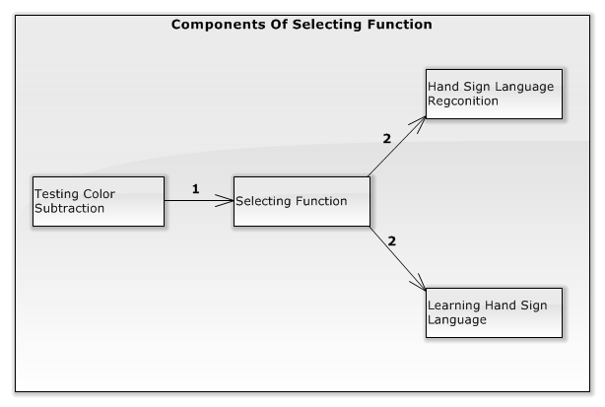

Figure 52: Components of the Selecting Function

#### Integration test case

|  |  |  |  |  |
| --- | --- | --- | --- | --- |
| **ID** | **Test Item(s)** | **Input Specification** | **Expected Output** | **Condition** |
| SFTC01 | Testing Color Subtraction -> Selecting Function | N/A | The images containing only the hand on the black background shows continuously. | Background Color Subtraction is executed. |
| These images must contain 2 rectangle areas inside, one has the sentences “Nhận dạng ngôn ngữ người câm” and another has the sentences “Học ngôn ngữ người câm”. |
| A notify “Hãy chọn chức năng mong muốn bằng cách đưa ký hiệu được hướng dẫn vào vùng chức năng đó” is shown. |
| SFTC02 | Selecting Function | Move the “select” hand sign into the “Nhận dạng ngôn ngữ người câm” rectangle area. | The images containing only the hand on the black background shows continuously. | SFTC01 is executed |
| “Nhận dạng ngôn ngữ người câm” rectangle area changes color to red color. |
| “Học ngôn ngữ người câm” rectangle area remains white color. |
| A notify “Hãy chọn chức năng mong muốn bằng cách đưa ký hiệu được hướng dẫn vào vùng chức năng đó” is shown. |
| SFTC03 | Selecting Function | Move the “select” hand sign outside the “Nhận dạng ngôn ngữ người câm” rectangle area. | The images containing only the hand on the black background shows continuously. | SFTC02 is executed. |
| “Nhận dạng ngôn ngữ người câm” rectangle area backs to white color. |
| “Học ngôn ngữ người câm” rectangle area remains white color. |
| A notify “Hãy chọn chức năng mong muốn bằng cách đưa ký hiệu được hướng dẫn vào vùng chức năng đó” is shown. |
| SFTC04 | Selecting Function | Show the “select” hand sign. | The images containing only the hand on the black background shows continuously. | SFTC03 is executed or SFTC08 is executed. |
| These images must contain 2 white rectangle area inside, one has the sentences “Nhận dạng ngôn ngữ người câm” and another has the sentences “Học ngôn ngữ người câm”. |
| A notify “Hãy chọn chức năng mong muốn bằng cách đưa ký hiệu được hướng dẫn vào vùng chức năng đó” is shown. |
| SFTC05 | Selecting Function | Show the “done” hand sign. | The images containing only the hand on the black background shows continuously. | SFTC03 is executed or SFTC08 is executed. |
| These images must contain 2 white rectangle area inside, one has the sentences “Nhận dạng ngôn ngữ người câm” and another has the sentences “Học ngôn ngữ người câm”. |
| A notify “Hãy chọn chức năng mong muốn bằng cách đưa ký hiệu được hướng dẫn vào vùng chức năng đó” is shown. |
| SFTC06 | Selecting Function -> Hand Sign Language Recognition | Change the “select” hand sign into “done” hand sign. | Hand Sign Language Recognition interface is displayed. | SFTC02 is executed |
| SFTC07 | Selecting Function | Move the “select” hand sign into the “Học ngôn ngữ người câm” rectangle area. | The images containing only the hand on the black background shows continuously. | SFTC01 is executed |
| “Học ngôn ngữ người câm” rectangle area changes color to red color. |
| “Nhận dạng ngôn ngữ người câm” rectangle area remains white color. |
| A notify “Hãy chọn chức năng mong muốn bằng cách đưa ký hiệu được hướng dẫn vào vùng chức năng đó” is shown. |
| SFTC08 | Selecting Function | Move the “select” hand sign outside the “Học ngôn ngữ người câm” rectangle area. | The images containing only the hand on the black background shows continuously. | SFTC07 is executed |
| “Học ngôn ngữ người câm” rectangle area backs to white color. |
| “Nhận dạng ngôn ngữ người câm” rectangle area remains white color. |
| A notify “Hãy chọn chức năng mong muốn bằng cách đưa ký hiệu được hướng dẫn vào vùng chức năng đó” is shown. |
| SFTC09 | Selecting Function -> Learning Hand Sign Language | Change the “select” hand sign into “done” hand sign. | Learning Hand Sign Language interface is displayed. | SFTC07 is executed |
| SFTC10 | Selecting Function | Show the hand signs differently from “select” and “done” hand sign. | The images containing only the hand on the black background shows continuously. | SFTC02 or SFTC07 is executed. |
| These images must contain 2 white rectangle area inside, one has the sentences “Nhận dạng ngôn ngữ người câm” and another has the sentences “Học ngôn ngữ người câm”. |
| “Học ngôn ngữ người câm” and “Nhận diện ngôn ngữ người câm” rectangle areas back to white color. |

#### Integration test procedure TP2

|  |  |  |  |  |  |  |
| --- | --- | --- | --- | --- | --- | --- |
| **ID** | **Purpose** | **Procedure Steps** | **Excuted By** | **Result** | **Test Date** | **Note** |
| SFTP01 | Test the flow selecting hand sign recognition can work correctly | 1. Execute test case SFTC01  2. Execute test case SFTC02  3. Execute test case SFTC06 |  | **Pass** |  |  |
| SFTP02 | Test the flow selecting learning hand sign flow can work correctly | 1. Execute test case SFTC01  2. Execute test case SFTC07  3. Execute test case SFTC09 |  | **Pass** |  |  |
| SFTP03 | Test “Selecting Function” can handle wrong steps selecting. | 1. Execute test case SFTC01  2. Execute test case SFTC02  3. Execute test case SFTC03  4. Execute test case SFTC04  5. Execute test case SFTC05 |  | **Pass** |  |  |
| SFTP04 | Test “Selecting Function” can handle wrong steps selecting. | 1. Execute test case SFTC01  2. Execute test case SFTC07  3. Execute test case SFTC08  4. Execute test case SFTC04  5. Execute test case SFTC05 |  | **Pass** |  |  |
| SFTP05 | Test “Selecting Function” can handle wrong hand signs. | 1. Execute test case SFTC01  2. Execute test case SFTC02  3. Execute test case SFTC10 |  | **Pass** |  |  |
| SFTP06 | Test “Selecting Function” can handle wrong hand signs. | 1. Execute test case SFTC01  2. Execute test case SFTC07  3. Execute test case SFTC10 |  | **Pass** |  |  |

### “Hand Sign Language Recognition” Test

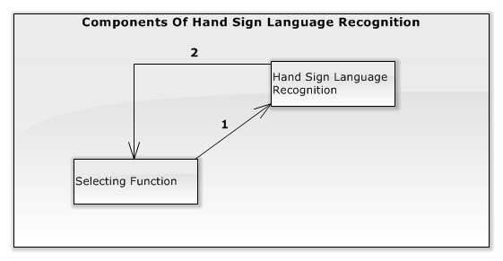

Figure 52: Components of the Hand Sign Language Recognition

#### Test Case Specification

|  |  |  |  |  |
| --- | --- | --- | --- | --- |
| **ID** | **Test Item(s)** | **Input Specification** | **Output Specification** | **Condition** |
| HSRTC01 | Selecting Function -> Hand Sign Recognition | N/A | The images containing only the hand on the black background shows continuously. | Hand Sign Language Recognition Function is selected. |
| A notify “Hệ thống sẽ lưu lại kết quả nhận dạng sau 3 giây” is shown. |
| Countdown time is shown by seconds from 3. |
| A label “Kết quả nhận dạng” is shown. |
| A label “Nội dung toàn bộ” is shown. |
| HSRTC02 | Hand Sign Language Recognition | Showing the “A” hand sign through camera. | The images containing only the hand on the black background shows continuously. | Test case HSRTC01 is executed |
| A notify “Hệ thống sẽ lưu lại kết quả nhận dạng sau 3 giây” is shown. |
| Countdown time is counting down. |
| A label “Kết quả nhận dạng” is shown with the result content “A” below. |
| A label “Nội dung toàn bộ” is shown.” |
| HSRTC03 | Hand Sign Language Recognition | Waiting for the countdown time counts to 0. | The images containing only the hand on the black background shows continuously. | Test case HSRTC02 is executed |
| A notify “Hệ thống sẽ lưu lại kết quả nhận dạng sau 3 giây” is shown. |
| A label “Kết quả nhận dạng” is shown with the result content “A” below. |
| A label “Nội dung toàn bộ” is updated with the content “A” below. |
| Countdown time is shown by seconds from 3 again. |
| HSRTC04 | Hand Sign Language Recognition | Showing the “B” hand sign through camera. | The images containing only the hand on the black background shows continuously. | Test case HSRTC03 is executed |
| A notify “Hệ thống sẽ lưu lại kết quả nhận dạng sau 3 giây” is shown. |
| Countdown time is counting down. |
| A label “Kết quả nhận dạng” is shown with result content “A” below. |
| A label “Nội dung toàn bộ” is shown with the old content “A” below. |
| HSRTC05 | Hand Sign Language Recognition | Waiting for the countdown time counts to 0. | The images containing only the hand on the black background shows continuously. | Test case HSRTC04 is executed |
| A notify “Hệ thống sẽ lưu lại kết quả nhận dạng sau 3 giây” is shown. |
| A label “Kết quả nhận dạng” is shown with result content “B” below. |
| A label “Nội dung toàn bộ” is updated with the content “A B” below. |
| Countdown time is shown by seconds from 3 again. |
| HSRTC06 | Hand Sign Language Recognition | Showing the “end” hand sign through camera. | The images containing only the hand on the black background shows continuously. | Test case HSRTC01 is executed |
| A notify “Hệ thống sẽ lưu lại kết quả nhận dạng sau 3 giây” is shown. |
| Countdown time is counting down. |
| A label “Kết quả nhận dạng” is shown with no result content. |
| A label “Nội dung toàn bộ” is shown with no updated content. |
| HSRTC07 | Hand Sign Language Recognition | Showing the “end” hand sign through camera. | The images containing only the hand on the black background shows continuously. | Test case HSRTC05 is executed |
| A notify “Hệ thống sẽ lưu lại kết quả nhận dạng sau 3 giây” is shown. |
| Countdown time is counting down. |
| A label “Kết quả nhận dạng” with no result content. |
| A label “Nội dung toàn bộ” is shown with the content “A B” below. |
| HSRTC08 | Hand Sign Language Recognition -> Selecting Function | Waiting for the countdown time counts to 0. | Selecting Function interface is displayed. | Test case HSRTC06 is executed |
| HSRTC09 | Hand Sign Language Recognition -> Selecting Function | Waiting for the countdown time counts to 0. | The images containing only the hand on the black background shows continuously. | Test case HSRTC07 is executed |
| A notify “Hệ thống sẽ di chuyển đến màn hình chọn chức năng sau khi nội dung được đọc xong” is shown. |
| A label “Kết quả nhận dạng” is shown with no result content. |
| A label “Nội dung toàn bộ” is updated with the content “A B” below. |
| The result content “A B” is read via LCD’s speaker. |
| Countdown time is not shown. |
| HSRTC10 | Hand Sign Language Recognition -> Selecting Function | Waiting for the entire result content is read completely. | Selecting Function interface is displayed. | Test case HSRTC09 is executed |

#### Integration Test Procedure TP3

|  |  |  |  |  |  |  |
| --- | --- | --- | --- | --- | --- | --- |
| **ID** | **Purpose** | **Procedure Steps** | **Excuted By** | **Result** | **Test Date** | **Note** |
| HSRTP01 | Test the flow Hand Sign Recognition can work correctly with the “A B” content. | 1. Execute test case HSRTC01  2. Execute test case HSRTC02  3. Execute test case HSRTC03  4. Execute test case HSRTC04  5. Execute test case HSRTC05  5. Execute test case HSRTC07  5. Execute test case HSRTC09  5. Execute test case HSRTC10 |  | **Pass** |  |  |
| HSRTP02 | Test the flow Hand Sign Recognition can work correctly with no content. | 1. Execute test case HSRTC01  2. Execute test case HSRTC06  3. Execute test case HSRTC08 |  | **Pass** |  |  |

### “Learning Hand Sign Language” Test

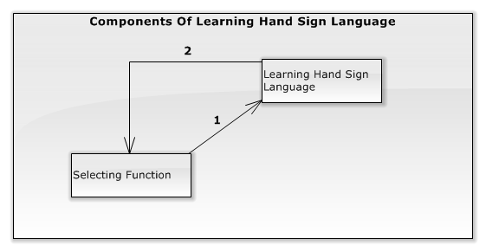

Figure 52: Components of the Selecting Function

#### Test case specification

|  |  |  |  |  |
| --- | --- | --- | --- | --- |
| **ID** | **Test Item(s)** | **Input Specification** | **Output Specification** | **Condition** |
| LHSTC01 | Selecting Function -> Learning Hand Sign Language | N/A | The images containing only the hand on the black background shows continuously. | Hand Sign Language Recognition Function is selected. |
| These images contains two white square area, one has “Up” arrow inside and the remaining has “Down” arrow inside. |
| The list of words is shown. |
| The “A” word is selected first. |
| Image describing “A” hand sign is displayed. |
| A notify “Hãy đưa kí hiệu trong hướng dẫn vào vùng mũi tên lên xuống để thay đổi từ được chọn ” is shown. |
| A label “Kết quả nhận dạng” is shown. |
| LHSTC02 | Learning Hand Sign Language | Move the “select” hand sign into the “Up” square area. | The images containing only the hand on the black background shows continuously. | Test case LHSTC01 is executed |
| “Up” square area changes color to red color. |
| “Down” square area remains white color. |
| A notify “Hãy đưa kí hiệu trong hướng dẫn vào vùng mũi tên lên xuống để thay đổi từ được chọn ” is shown. |
| The list of words is shown. |
| The “A” word in the list still is selected. |
| Image describing “A” hand sign is displayed. |
| A label “Kết quả nhận dạng” with no result content below. |
| LHSTC03 | Learning Hand Sign Language | Move the “select” hand sign into the “Down” square area. | The images containing only the hand on the black background shows continuously. | Test case LHSTC01 is executed |
| “Down” square area changes color to red color. |
| “Up” square area remains white color. |
| A notify “Hãy đưa kí hiệu trong hướng dẫn vào vùng mũi tên lên xuống để thay đổi từ được chọn ” is shown. |
| The list of words is shown. |
| The “A” word in the list still is selected. |
| Image describing “A” hand sign is displayed. |
| A label “Kết quả nhận dạng” with no result content below. |
| LHSTC04 | Learning Hand Sign Language | Move the “select” hand sign outside the “Up” and “Down” square area. | The images containing only the hand on the black background shows continuously. | Test case LHSTC02 is executed or LHSTC03 is executed |
| These images contains two white square area, one has “Up” arrow inside and the remaining has “Down” arrow inside. |
| A notify “Hãy đưa kí hiệu trong hướng dẫn vào vùng mũi tên lên xuống để thay đổi từ được chọn ” is shown. |
| The list of words is shown. |
| The “A” word in the list still is selected. |
| Image describing “A” hand sign is displayed. |
| A label “Kết quả nhận dạng” with no result content below. |
| LHSTC05 | Learning Hand Sign Language | Show the “done” hand sign. | The images containing only the hand on the black background shows continuously. | Test case LHSTC04 is executed. |
| “Up” rectangle area remains white color. |
| “Down” square area remains white color. |
| A notify “Hãy đưa kí hiệu trong hướng dẫn vào vùng mũi tên lên xuống để thay đổi từ được chọn ” is shown. |
| The list of words is shown. |
| The “A” word in the list still is selected. |
| Image describing “A” hand sign is displayed. |
| A label “Kết quả nhận dạng” with no result content below. |
| LHSTC06 | Learning Hand Sign Language | Show the “done” hand sign. | The images containing only the hand on the black background shows continuously. | Test case LHSTC03 is executed |
| These images contains two white square area, one has “Up” arrow inside and the remaining has “Down” arrow inside. |
| A notify “Hãy đưa kí hiệu trong hướng dẫn vào vùng mũi tên lên xuống để thay đổi từ được chọn ” is shown. |
| The list of words is shown. |
| The selected word is down by one. |
| Image describing selected word hand sign is displayed. |
| A label “Kết quả nhận dạng” with no result content below. |
| LHSTC07 | Learning Hand Sign Language | Show the “done” hand sign. | The images containing only the hand on the black background shows continuously. | Test case LHSTC06 is executed, then LHSTC02 is executed. |
| These images contains two white square area, one has “Up” arrow inside and the remaining has “Down” arrow inside. |
| A notify “Hãy đưa kí hiệu trong hướng dẫn vào vùng mũi tên lên xuống để thay đổi từ được chọn ” is shown. |
| The list of words is shown. |
| The selected word is up by one. |
| Image describing selected word hand sign is displayed. |
| A label “Kết quả nhận dạng” with no result content below. |
| LHSTC08 | Learning Hand Sign Language | Showing the “B” hand sign inside of the two square areas “Up” or “Down”. | The images containing only the hand on the black background shows continuously. | Test case LHSTC01 is executed |
| These images contains two white square area, one has “Up” arrow inside and the remaining has “Down” arrow inside. |
| A notify “Hãy đưa kí hiệu trong hướng dẫn vào vùng mũi tên lên xuống để thay đổi từ được chọn ” is shown. |
| The list of words is shown. |
| The “A” word in the list still is selected. |
| Image describing selected word hand sign is displayed. |
| A label “Kết quả nhận dạng” with the result content “B” below. |
| “B” word is read via LCD’s speaker. |
| LHSTC09 | Learning Hand Sign Language | Showing the “B” hand sign outside of the two square areas “Up” and “Down”. | The images containing only the hand on the black background shows continuously. | Test case LHSTC01 is executed |
| These images contains two white square area, one has “Up” arrow inside and the remaining has “Down” arrow inside. |
| A notify “Hãy đưa kí hiệu trong hướng dẫn vào vùng mũi tên lên xuống để thay đổi từ được chọn ” is shown. |
| The list of words is shown. |
| The “A” word in the list still is selected. |
| Image describing selected word hand sign is displayed. |
| A label “Kết quả nhận dạng” with the result content “B” below. |
| “B” word is read via LCD’s speaker. |
| LHSTC10 | Learning Hand Sign Language -> Selecting Function | Showing the “end” hand sign inside of the two square areas “Up” or “Down”. | Selecting Function interface is displayed | Test case LHSTC01 is executed |
| LHSTC11 | Learning Hand Sign Language -> Selecting Function | Showing the “end” hand sign outside of the two square areas “Up” and “Down”. | Selecting Function interface is displayed | Test case LHSTC01 is executed |

#### Integration Test Procedure TP4

|  |  |  |  |  |  |
| --- | --- | --- | --- | --- | --- |
| **ID** | **Purpose** | **Procedure Steps** | **Result** | **Test Date** | **Note** |
| LHSTP01 | Test the flow Learning Hand Sign Language can work correctly.  Test the “Learning Hand Sign Language” can handle the correct “end” hand sign. | 1. Execute test case HSRTC01  2. Execute test case HSRTC02  3. Execute test case HSRTC04  4. Execute test case HSRTC05  5. Execute test case HSRTC09  6. Execute test case HSRTC11 | **Pass** |  |  |
| LHSTP02 | Test the flow Learning Hand Sign Language can work correctly.  Test the “Learning Hand Sign Language” can handle the incorrect “end” hand sign.  Test the “Up” function can work correctly with incorrect “done” hand sign. | 1. Execute test case HSRTC01  2. Execute test case HSRTC02  3. Execute test case HSRTC04  4. Execute test case HSRTC05  5. Execute test case HSRTC09  6. Execute test case HSRTC10 | **Pass** |  |  |
| LHSTP03 | Test the flow Learning Hand Sign Language can work correctly.  Test the “Down” function can work correctly with incorrect “done” hand sign. | 1. Execute test case HSRTC01  2. Execute test case HSRTC03  3. Execute test case HSRTC04  4. Execute test case HSRTC05  5. Execute test case HSRTC09  6. Execute test case HSRTC10 | **Pass** |  |  |
| LHSTP04 | Test the flow Learning Hand Sign Language can work correctly.  Test the “Down” and “Up” function can work correctly with correct “select” hand sign. | 1. Execute test case HSRTC01  2. Execute test case HSRTC02  3. Execute test case HSRTC03  4. Execute test case HSRTC09  5. Execute test case HSRTC10 | **Pass** |  |  |
| LHSTP05 | Test the flow Learning Hand Sign Language can work correctly.  Test the “Down” and “Up” function can work correctly with correct “done” hand sign. | 1. Execute test case HSRTC01  2. Execute test case HSRTC03  3. Execute test case HSRTC06  4. Execute test case HSRTC02  5. Execute test case HSRTC07 | **Pass** |  |  |
| LHSTP06 | Test the flow Learning Hand Sign Language can work correctly.  Test the “Hand Sign Recognition” still works correctly. | 1. Execute test case HSRTC01  2. Execute test case HSRTC03  3. Execute test case HSRTC06  4. Execute test case HSRTC09  5. Execute test case HSRTC11 | **Pass** |  |  |

### “Monitor Battery Capacity” Test

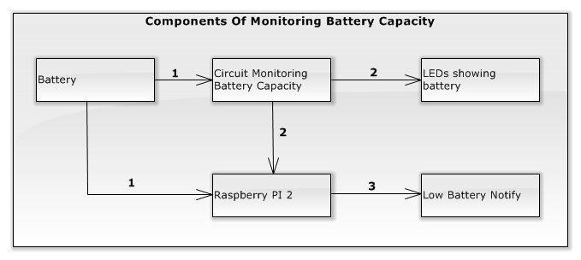

Figure 52: Components of the ???

#### Integration test case

|  |  |  |  |  |
| --- | --- | --- | --- | --- |
| **ID** | **Test Item(s)** | **Input Specification** | **Output Specification** | **Condition** |
| MBCTC01 | Battery -> Battery Capacity Display Circuit -> LEDs showing battery | Switch on | LED on circuit is bright. | The battery voltage > 9.8V |
| MBCTC02 | Battery -> Battery Capacity Display Circuit -> LEDs showing battery | The battery voltage is higher 12V | 4 LEDs on circuit is bright. | Test case MBCTC01 is exectuted |
| MBCTC03 | Battery -> Battery Capacity Display Circuit -> LEDs showing battery | The battery voltage is between 11.3V and 12V | 3 LEDs on circuit is bright. | Test case MBCTC01 is exectuted |
| MBCTC04 | Battery -> Battery Capacity Display Circuit -> LEDs showing battery | The battery voltage is between 11.3V and 10.8V | 2 LEDs on circuit is bright. | Test case MBCTC01 is exectuted |
| MBCTC05 | Battery -> Battery Capacity Display Circuit -> LEDs showing battery | The battery voltage is between 10.8V and 9.9V | 1 LEDs on circuit is bright. | Test case MBCTC01 is exectuted |
| MBCTC06 | Battery -> Battery Capacity Display Circuit -> LEDs showing battery | The battery voltage is lower 9.9V | 4 LEDs on circuit is off. | Test case MBCTC01 is exectuted |
| MBCTC07 | Battery -> Battery Capacity Display Circuit -> Raspbbery PI 2 | N/A | LED on Raspberry is bright. | Test case MBCTC01 is executed |
| MBCTC08 | Raspbbery PI 2 -> Low Battery Notify | The battery voltage is between 9.8V and 10.5V | Low Battery Notify “Bin yếu vui lòng tắt hệ thống và cắm sạc. Thông báo sẽ được tự động tắt.” is shown on the system interfaces. | Test case MBCTC02 is executed |
| Countdown time is shown in Low Battery Notify by seconds from 3. |
| MBCTC09 | Raspbbery PI 2 -> Low Battery Notify | The battery voltage is between ..V and ..V | Low Battery Notify is not displayed. |  |
| MBCTC10 | Raspbbery PI 2 -> Low Battery Notify | Waiting for the countdown time counts to 0. | Low Battery Notify is hide. | Test case MBCTC03 is executed |

#### Integration test procedure

|  |  |  |  |  |  |  |
| --- | --- | --- | --- | --- | --- | --- |
| **ID** | **Purpose** | **Procedure Steps** | **Excuted By** | **Result** | **Test Date** | **Note** |
| MBCTP01 | Test the flow Monitoring Battery Capacity works correctly with low battery. | 1. Execute test case MBCTC01  2. Execute test case MBCTC07  3. Execute test case MBCTC05  4. Execute test case MBCTC08  5. Execute test case MBCTC10 |  | **Pass** |  |  |
| MBCTP02 | Test the flow Monitoring Battery Capacity works correctly with normal battery. | 1. Execute test case MBCTC01  2. Execute test case MBCTC07  3. Execute test case MBCTC04  4. Execute test case MBCTC09  5. Execute test case MBCTC10 |  | **Pass** |  |  |
| MBCTP01 | Test the displaying battery capacity on LEDs. | 1. Execute test case MBCTC01  2. Execute test case MBCTC02 |  | **Pass** |  |  |
| MBCTP01 | Test the displaying battery capacity on LEDS. | 1. Execute test case MBCTC01  2. Execute test case MBCTC03 |  | **Pass** |  |  |
| MBCTP01 | Test the displaying battery capacity on LEDs. | 1. Execute test case MBCTC01  2. Execute test case MBCTC04 |  | **Pass** |  |  |

### “Charging Battery” Test

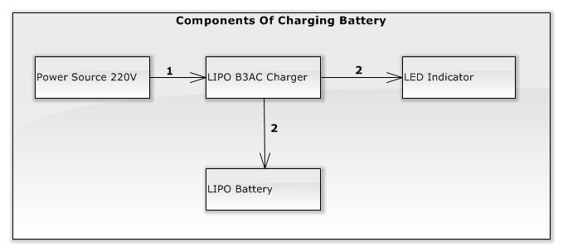

Figure 52: Components of the ???

#### Integration test case

|  |  |  |  |  |
| --- | --- | --- | --- | --- |
| **ID** | **Test Item(s)** | **Input Specification** | **Output Specification** | **Condition** |
| CBTC01 | 220V power source -> LIPO B3AC charger -> Led Indicator | Connect LIPO B3AC charger to power source | The charger’s LEDs indicator is bright with red color. | The system is OFF. |
| CBTC02 | LIPO B3AC charger -> LIPO Battery | Connect LIPO B3AC charger to LIPO Battery has the voltage lower 9.8V. | The charger’s LEDs indicator is bright with red color. | Test case CBTC01 is executed. |
| CBTC03 | LIPO B3AC charger -> LIPO Battery | Waiting for about ?? minutes. | One Charger’s LED is bright with green color. | Test case CBTC02 is executed. |
| CBTC04 | LIPO B3AC charger -> LIPO Battery | Waiting for about ?? minutes. | Two Charger’s LEDs are bright with green color. | Test case CBTC02 is executed. |
| CBTC05 | LIPO B3AC charger -> LIPO Battery | Waiting for about ?? minutes. | Three Charger’s LEDs are bright with green color. | Test case CBTC02 is executed. |

#### Integration test procedure

|  |  |  |  |  |  |  |
| --- | --- | --- | --- | --- | --- | --- |
| **ID** | **Purpose** | **Procedure Steps** | **Excuted By** | **Result** | **Test Date** | **Note** |
| CBIPT01 | Test the charging battery flow can succeed and work stability. | 1. Execute test case CBTC01  2. Execute test case CBTC02  3. Execute test case CBTC03 |  | Pass |  |  |
| CBIPT02 | Test the charging battery flow can succeed and work stability. | 1. Execute test case CBTC01  2. Execute test case CBTC02  3. Execute test case CBTC04 |  | Pass |  |  |
| CBIPT03 | Test the charging battery flow can succeed and work stability. | 1. Execute test case CBTC01  2. Execute test case CBTC02  3. Execute test case CBTC05 |  | Pass |  |  |